Number : 005/OR/ALt/ALSAIB/I/2020
Attachment : Appendix A (IB Directors Proposal)
Concerning : Open Application for ALSA International Board Director 2019/2020
03rd January 2020
Dear National Chapters,
This letter serves to inform you that the application for ALSA International Board Director 2019/2020 is now open under Department of Secretary-General. The position is as follow:
- Director of Transcription and Communication

The candidate(s) is required to submit the following application documents:
- Motivational Letter;
- Curriculum Vitae;
- Action Plan (2020);
- Recommendation Letter from National Chapter.

The candidates that are willing to apply the stated position can refer the work scope of the Director in Appendix A.
Should the candidate(s) have further queries regarding the position, please contact the respective officers:

Secretary General
Sheikh Wa’ez Hj Sheikh Aubid : sec_gen@alsainternational.org

The application will be open until 17th January 2020. As well as for National Chapters to conduct a fit and proper test beforehand to make sure the candidate has meet qualifications expected. Please submit the applications from your candidate(s) collectively to sec_gen@alsainternational.org.

Respectfully Yours,

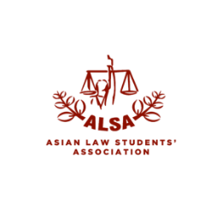
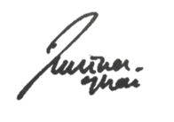
Amalina Ghani
President
Asian Law Students’ Association
International Board
2019/2020

