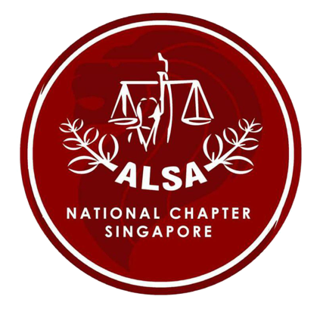
ALSA Annual Forum 2017 in SINGAPORE
Application Form

ALSA Singapore National Chapter

31st July ~ 6 August 2017

THINGS TO NOTE:
- The registration fee for the study trip is $500 USD. The fee covers accommodation, most meals, and transportation. However, the cost of airfare, travel insurance, free-and-easy meals etc are not included.
- Please send in this application form and the payment directly to your local chapters or national chapters; they will then collate and send them to us at: af2017singapore@gmail.com.
- The deadline for NCs to send in the application forms to ALSA Singapore is 9th June (Friday). Payment from the NCs should be sent in by 14th June (Wednesday).
- Please save the file name as follows: “Full name (National Chapter)”. For example, “Thomas Lee (Singapore)”.

If you have any further enquiries, please do not hesitate to contact us at af2017singapore@gmail.com.

WITHDRAWAL POLICY
We do understand that delegates’ schedules may be subject to change; however, some of the payments for the Annual Forum need to be made ahead of time. Thus, if we are notified of a delegate’s withdrawal by 30th June (Friday), we will refund $175 USD from the total registration fee paid. No refund will be provided for withdrawals after this date.

REGISTRATION FORM

Personal particulars
Full name (underline family name)
Date of birth (DD/MM/YYYY)
Blood type
Passport Number
Passport expiry date
Nationality
Home Address
Email Address
Phone Number (with country code)

Organisation information
University
National Chapter

Health information
Food Allergies
Dietary preference

Emergency contact
Person to contact (relationship)
Contact number

Programme choices
Preferred academic topic
(Please rank all choices in order of preference; if you are doing GCM just indicate “GCM” without ranking)
Preferred non-academic route
(Please rank all choices in order of preference)
Indemnity Agreement

Agreement of Indemnification dated [Date] between Asian Law Students’ Association, Singapore National Chapter (“ALSA Singapore”) and the Undersigned [Delegate’s Full Name].
- PURPOSE OF AGREEMENT
  - The purpose of this Agreement is to ensure that delegates are willing to provide specific costs that the Organising Committee of the ALSA Annual Forum in Singapore 2017 (“AF”) shall pay in advance in regards to the confirmed reservation on behalf of the delegates throughout the period of the AF. These include costs for accommodation, transportation, and catering.
- These costs are generally non-refundable.

- CONDITION OF PARTICIPATION
- Once an applicant has completed the registration process, the Organising Committee shall not accept any withdrawals, unless there are extenuating circumstances.
- The Organising Committee will only recognise a participating delegate once they have made payment.
- The delegates are hereby notified that by signing this indemnity form, the delegate agrees to bear all relevant costs of the AF, stated in clause 2.2, to the Organising Committee, regardless of their actual participation in the AF.
- Lack of participation in certain activities of the AF will not exempt the delegate from their obligation to pay the registration fee.
- The Organising Committee will not be held responsible for any injury caused during the cause of the AF, except by reason of the Committee’s negligence.

Delegate’s Full Name：
University：
Country (National Chapter)：
National Identification Number：

Signature：
Please also attach a copy of your PASSPORT:

